Ex.No: 6a | DATA VISUALIZATION USING POWER BI

AIM:
To import, transform, analyze, and visualize data using Power BI Desktop and create interactive dashboards and reports for decision-making..

ALGORITHM 1:
Step 1: Open Power BI desktop application.
Step 2: Select: Home → Get Data
Step 3: Choose Excel or CSV
Step 4: Browse dataset
Step 5: Click Load
Step 6: Verify Imported data
PROCEDURE:
Home Screen
Home
|
|-- Get Data
|-- Excel
|-- CSV
|-- SQL Server

OUTPUT:
Imported dataset displayed in Data View.
Product Region Sales
Laptop | North | 50000
Mobile | South | 35000
Printer | East | 25000

ALGORITHM 2:
Data Transformation using Power Query
Step 1: Select Transform Data
Step 1: Open Power Query Editor.
Step 3: Remove duplicates
Step 4: Handle null values
Step 5: Rename columns
Step 6: Apply changes.
Example Transformation Before
Product Sales
Laptop 50000
Mobile Null
Printer 25000
After
Product Sales
Laptop 50000
Mobile 35000
Printer 25000

OUTPUT:
Cleaned dataset loaded successfully.

ALGORITHM 3:
Creating a Bar Chart
Step 1: Choose Bar Chart Visualization
Step 2: Drag Product → Axis
Step 3: Drag Sales → Values
Step 4: Format chart
OUTPUT:
Visualization Product-wise Sales
Sales comparison across products.

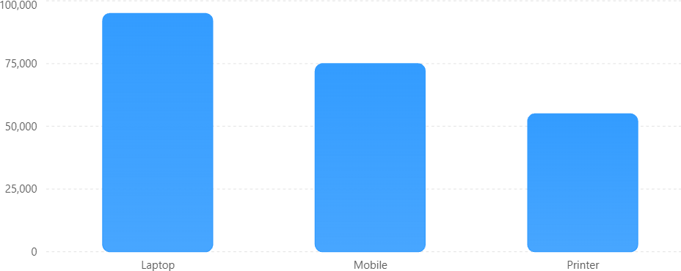

Interpretation
Laptop generated highest sales. Printer generated lowest sales.
ALGORITHM 4:
Creating a Pie Chart
Step 1: Select Pie Chart
Step 2: Drag Product → Legend
Step 3: Drag Sales → Values
Step 4: Apply Data Labels
OUTPUT:
Visualization
Sales Contribution
Percentage contribution of each product.
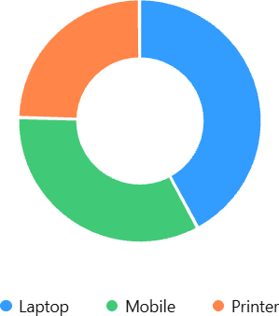

Interpretation
Laptop contributes the highest share of total sales.

ALGORITHM 5
Creating a KPI Card
Step 1: Select Card Visualization
Step 2: Drag Sales Field
Step 3: Apply Formatting

DAX Formula Total Sales

Total Sales = ∑𝑺𝒂𝒍𝒆𝒔

DAX Measure
Total Sales = SUM(Sales[Sales])

OUTPUT:
KPI Value Total Sales 225000
ALGORITHM 6:
Creating Slicers
Step 1: Select Slicer Visualization Step
Step 2: Drag Region Field
Step 3: Enable Single Selection
Step 4: Apply Filters

OUTPUT:
Available Filters:
- North
- South
- East
- West Dashboard Behavior When North is selected:
Product Sales Laptop 50000
Mobile 40000
Dashboard automatically updates.
ALGORITHM 7:
Creating DAX Calculations Average Sales
Average Sales = AVERAGE(Sales[Sales])

Maximum Sales

Maximum Sales = MAX(Sales[Sales])

Minimum Sales
Minimum Sales = MIN(Sales[Sales])
OUTPUT:
Measure Value
Average Sales 37500

Maximum Sales 50000
Minimum Sales 25000
ALGORITHM 8:
Creating Dashboard
Step 1: Add KPI Card
Step 2: Add Bar Chart
Step 3: Add Pie Chart
Step 4: Add Slicer
Step 5: Arrange Visuals
Step 6: Save Dashboard

Dashboard Layout

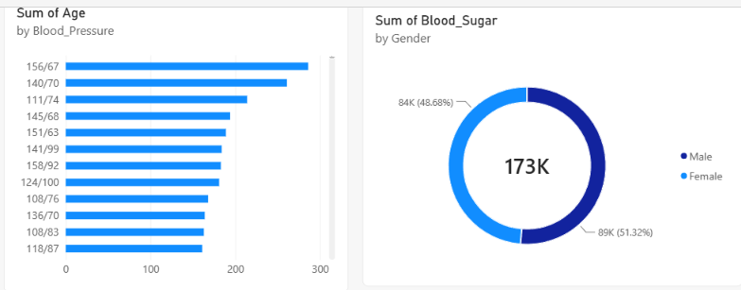

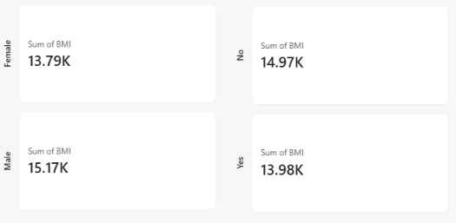

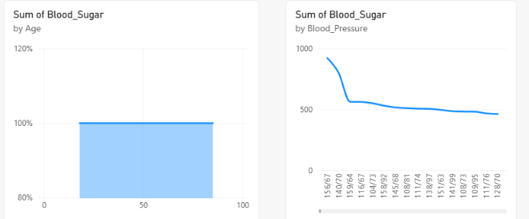

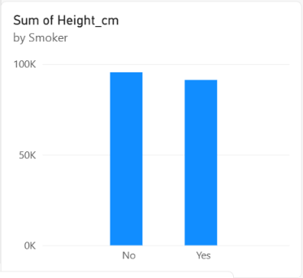

RESULT:
Thus, various visualization techniques such as Line Charts, Bar Charts, Pie Charts, Histograms, Scatter Plots, and Box Plots were successfully created using Matplotlib. The graphical representations helped in understanding trends, distributions, comparisons, and relationships within the dataset.

